**Sign in to Teams**

1. Download the Microsoft **Teams** App and sign in with your **school** computer login i.d.

(ex: htech1234@slps.org) and password.

1. When you see your class tile, click on it to start connecting with your teacher and classmates!

**Hodgen Pre-K Inclusion Rm. 106 Petty/Holmes**



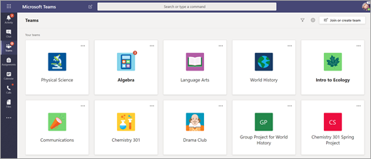



Channels

Every class team has a main discussion area, the **General** channel. Under **General**, your teacher may create more channels to organize topics, projects, and more.

* All channels include a **Posts** and a **Files** tab.
* The **Posts** tab is where you, your classmates, and your teacher can all start and reply to conversations.
* Look for shared documents in the **Files** tab.
* Along with **Posts** and **Files** tabs, the **General** channel has **Assignments, Class Notebook**, and**Grades** tabs.

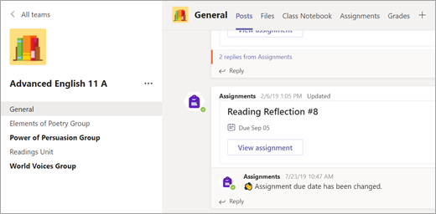



Notifications

Check the **Activity** feed to make sure you don’t miss a new assignment or an @mention.

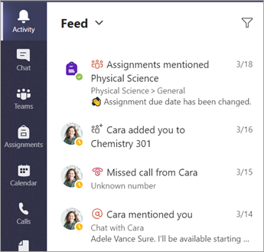



View and turn in assignments

1. Head to your class team and the **General** channel. Select the **Assignments**tab.
2. To *view* assignment details and turn in work, select the assignment.
3. Attach any required materials, and select **Turn in**.

